Non-odor complaint VN
Odor complaint VN
More information required

VN_20140414.pdf – April 14, 2014
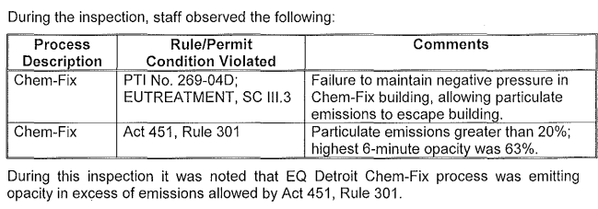
Response: M4545_RVN_20140512

VN_20140522.pdf - May 22, 2014

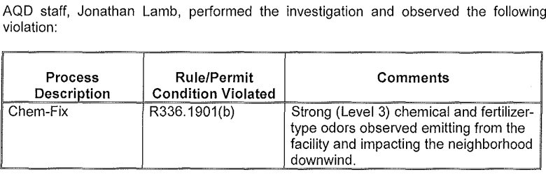

Response: RVN_20140619.pdf

VN_20140623.pdf – June 23, 2014

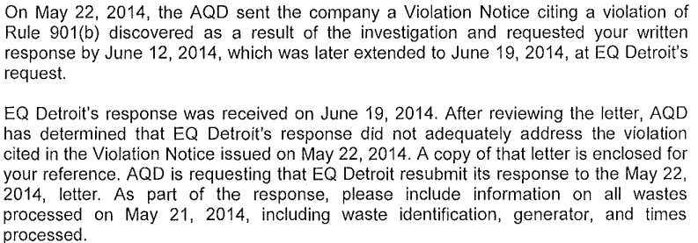

Response: RVN_20140707.pdf

VN_20150825.pdf – August 25, 2015

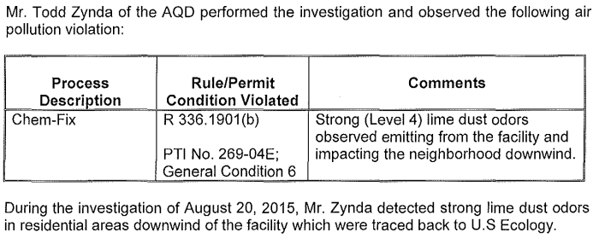

No Response document in EGLE system

VN_20151012.pdf – October 12, 2015

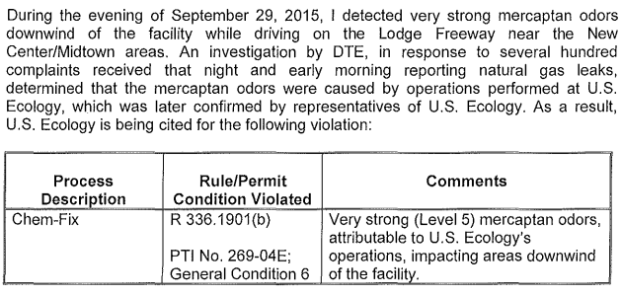

Response: VN_20151027.pdf

VN_20160721.pdf – July 21, 2016

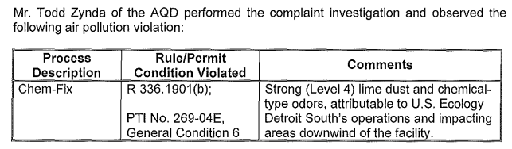

Response: See below SAR_20160819.pdf

VN_20160803.pdf – August 3, 2016

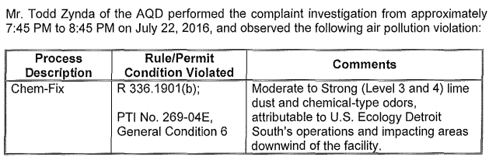

No response letter in EGLE system but a scheduled activity report from an onsite inspection states the following:

COMPLAINT/COMPLIANCE HISTORY: The facility has a long history of odor issues dating back to 1995. Since the last inspection on August 27, 2015, the facility has been issued three Violation Notices, dated October 12, 2015, July 21, 2016, and August 3, 2016, for emitting nuisance odors in violation of Rule 901. These odors are suspected to be associated with the waste stabilization/solidification process. At the time of inspection, the outstanding violation notices were unresolved and the facility was considered to be in noncompliance with Rule 901.

Note: When investigating complaints alleging odors from EQ Detroit, the inspector should also consider Greater Detroit Resource Recycling as a possible source, especially if the complaint is nondescript, or if the odors are described as "rotting" or "garbage". Both sources have potential for off-site odors; however, the odor from each source is distinctly different in character.

SAR_20160819.pdf – August 19, 2016

VN_20160923.pd – September 23, 2016

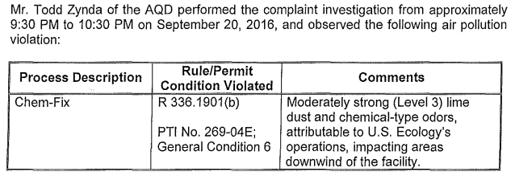

Response: RVN_20161013.pdf (also for October 4, 2016 complaint)

VN_20161004.pdf – October 4, 2016

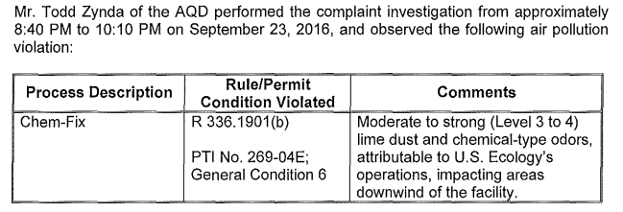

Response: RVN_20161013.pdf (also for October 4, 2016 complaint)

VN_20161123.pdf – November 23, 2016

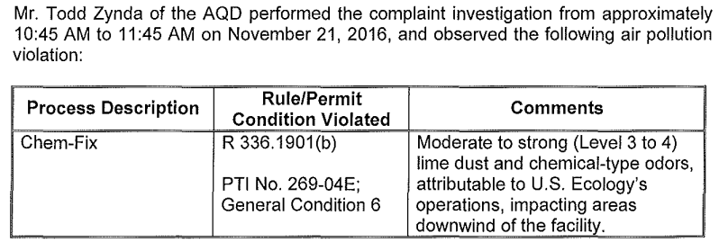

Response: RVN_20161214

VN_20170126 – January 26, 2017

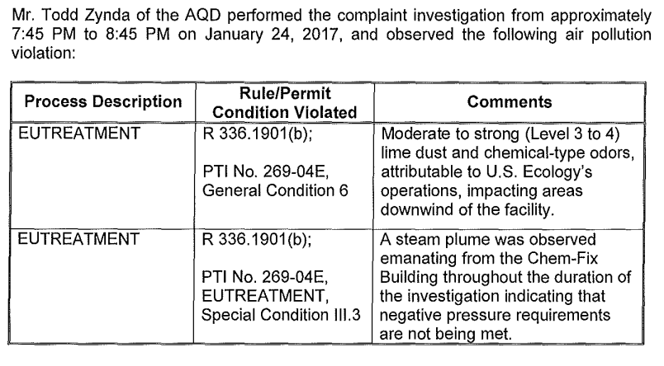

Response: RVN_2017021

VN_20170427 – April 27, 2017

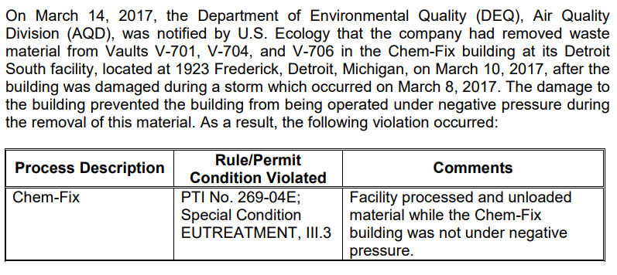

Response: RVN_2017051

VN_20170815.pdf – August 15, 2017

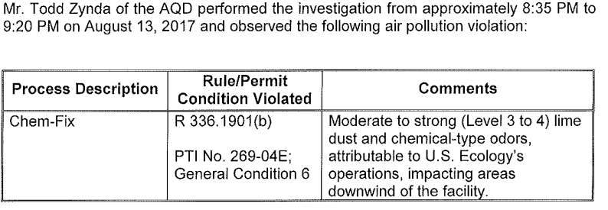

Response: RVN_20170831

VN_20180620.pdf – June 20, 2018

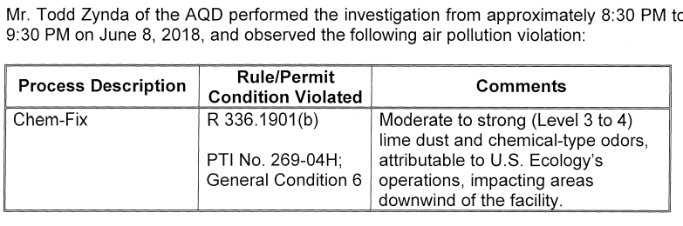

Response: RVN_20180711

VN_20180731.pdf – July 31, 2018

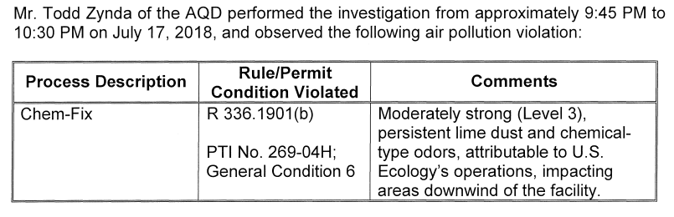

Response: RVN_20180813

VN_20180808.pdf – August 8, 2018

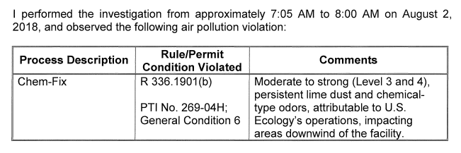

Response: RVN_20180813

VN_20180920.pdf – September 20, 2018

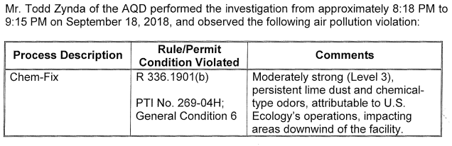

Response: RVN_20181009

VN_20190909.pdf – September 9, 2019

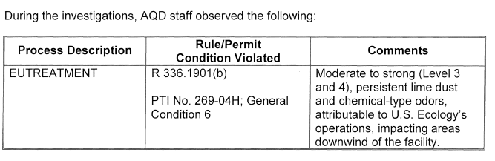

Response: RVN_20190919

VN_20200422.pdf – April 22, 2020

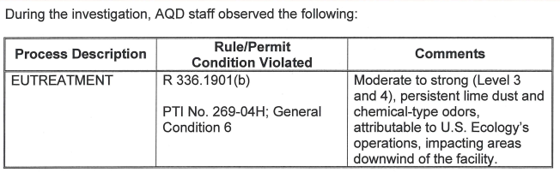

Response: RVN_20200513

VN_20200622 – June 22, 2020

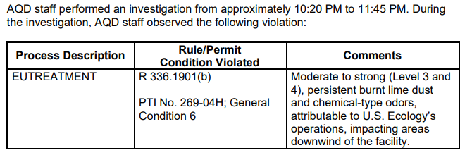

Response: RVN_20200713

VN_20200824 – August 24, 2020

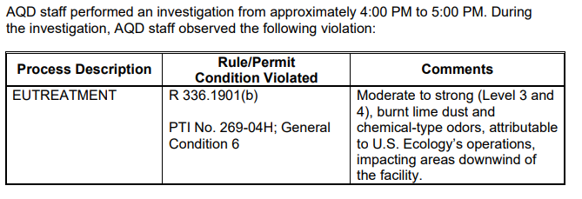

Response: RVN_20200914

VN_20200917 – September 17, 2020

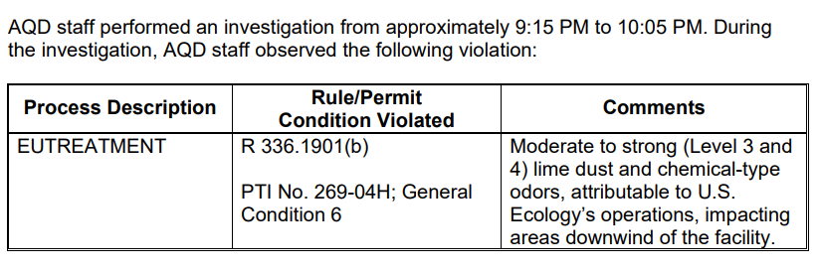
Response: RVN_20201009

VN_20201027 – October 27, 2020

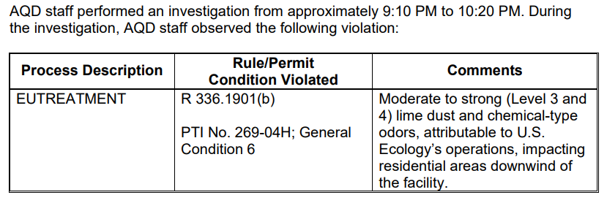
Response: RVN_20201116

VN_20201207 – December 7, 2020

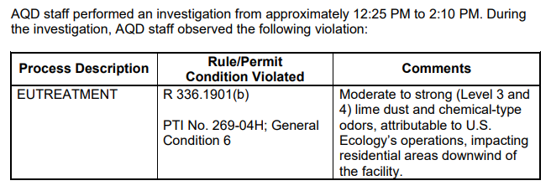
Response: RVN_20201218 (scentometer explained)

VN_20210726 – July 28, 2021

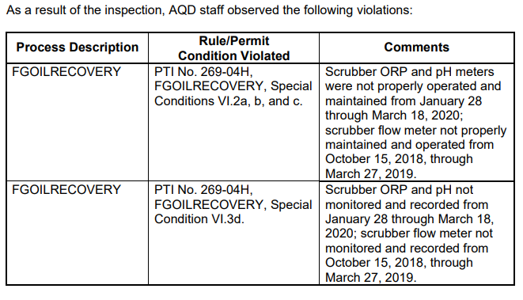
Response: RVN_20210813

VN_20211007 – October 7, 2021

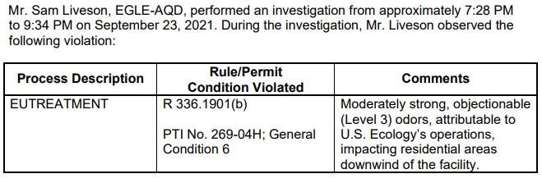

Response: RVN_20211028

VN_20211101 – November 1, 2021

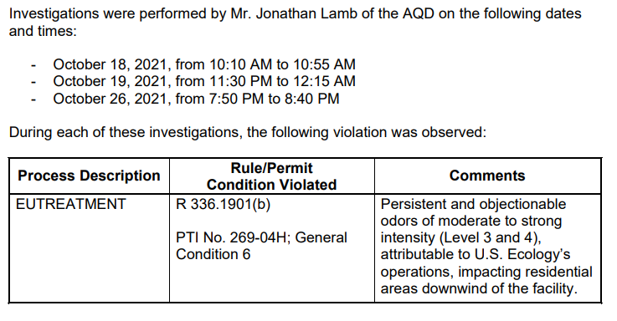
Response: RVN_20211119

